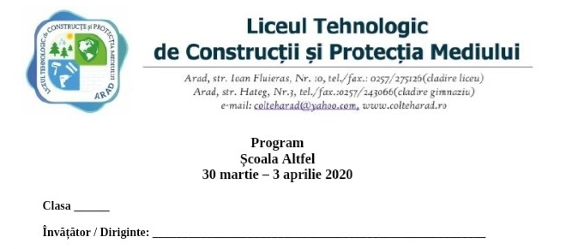
Program ,, Săptămâna Școala Altfel" - clasa VIII B , Prof.Irimia Cristian

Ziua | Denumire activitate | Link / Mod de Desfasurare
Luni 30 Martie 2020 | Histoire audio : Le Poisson d’Or | https://parlez-vous-french.com/histoire-audio-le-poisson-dor
Marti 31 Martie 2020 | Men Sana in corpore Sano | https://www.youtube.com/watch?v=LUrrN6cEBRQ&feature=youtu.be
Miercuri 1 Aprilie 2020 | Vizita Muzeu | https://artsandculture.google.com/partner/musee-dorsay-paris?hl=en
Joi 2 Aprilie 2020 | Surviving with english | http://learnenglishteens.britishcouncil.org/study-break/graded-listening
Vineri 3 Aprilie 2020 | Cultura generala (explorarea lumii) | https://www.youtube.com/watch?v=-EOG8oALxt0&feature=youtu.be

